MPU6050 experiment
Mpu6050 is the first version to combine 3-axis gyroscope, 3-axis accelerator, with 9-shaft calculation technology.

Application:
movement sensing game
Augmented reality
EIS: Electronic Image Stabilization
OIS: Optical Image Stabilization
passenger navigator
”Zero touch” gesture user interface
gesture shortcut
Market for certification:
Intelligent mobile phone
Tablet devices
Handheld game products
Game console
3D remote control
Portable navigation devices

Circuit connection:
A4 to SDA
A5 to SCL
VCC to 3.3V (or 5V, but better use 3.3V for damage concerns)
GN to GND.

See below photo:
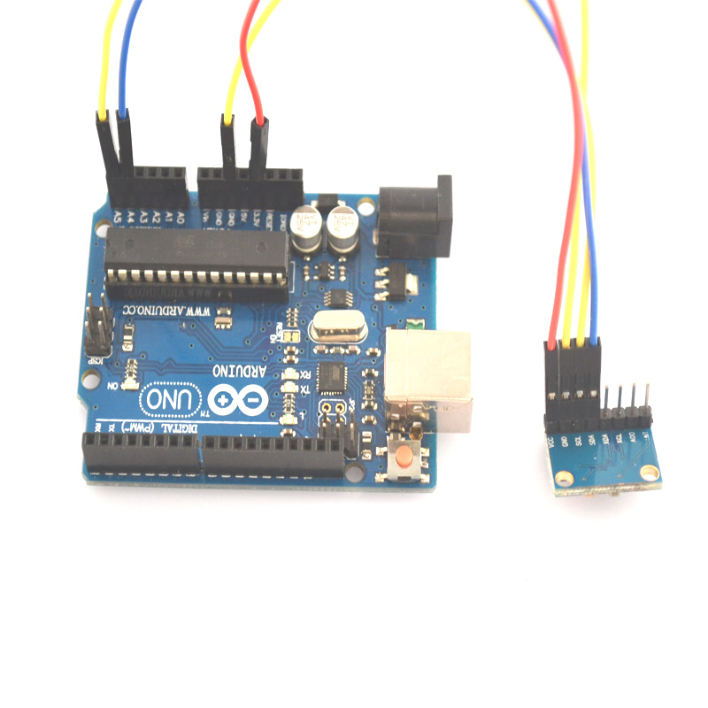

But the precision of mpu is greatly affected by temperature.

Program:
#include "Wire.h"
#include "I2Cdev.h"
#include "MPU6050.h"
MPU6050 accelgyro;

int16_t ax, ay, az;
int16_t gx, gy, gz;

bool blinkState = false;

void setup() {

Wire.begin();
Serial.begin(38400);

accelgyro.initialize();
}
void loop() {

accelgyro.getMotion6(&ax, &ay, &az, &gx, &gy, &gz);
Serial.print("a/g:\t");
Serial.print(ax/16384); Serial.print("\t");
Serial.print(ay/16384); Serial.print("\t");
Serial.print(az/16384); Serial.print("\t");
Serial.print(gx/131); Serial.print("\t");
Serial.print(gy/131); Serial.print("\t");
Serial.println(gz/131);
blinkState = !blinkState;

}
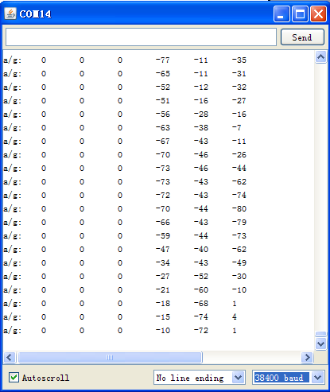
There are some deviations of the above results because they are before calibration. This is just for your reference for everyone. I hope it helps. Thanks!

